Faculty of Engineering and Computer Science
Department of Mechanical Engineering



ENGR-391 Numerical methods for Engineers

Student’s Name:

I.D.:

Duration 3 hours

PROBLEM 1 [Solving Nonlinear Equations] [5 marks]

Solve the following nonlinear equation using the secant method with x₀=2.0 and x₁=1.0:

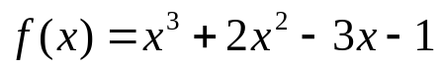

Give the answer with 4 significant digits.
Check your result and discuss.

PROBLEM 2 [Solving Systems of Linear Equations] [5 marks]

a) Find the LU decomposition of following matrix:

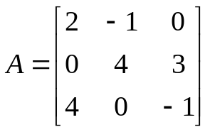

Check your results

b) Compute the determinant of A

PROBLEM 3 [Numerical Integration] [5 marks]

Compute the following integral:

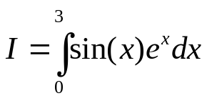
Using multi-segment Trapezoidal rule with two segments (n=2) and with four segments (n=4).

Estimate your global truncation error and give your answer with an appropriate number of significant digits.

Hint: The order in the global truncation error of the trapezoidal rule in its multiple application is order 2.

PROBLEM 4 [Solving Ordinary Differential Equations] [5 marks]

Solve the following ODE:

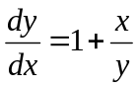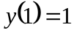

a) Using Euler’s method, for 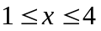 and a step of 0.5.

b) Using Euler’s method, for and a step of 0.25.

c) Estimate your error in x=4 using the Richardson formula and provide an answer with the correct number of significant digits for 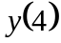.

PROBLEM 5 [20 marks]

- Suppose we have developed a differential equation solution technique in order 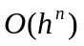 (for the local truncation error). If 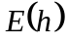 and 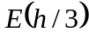 are the global truncation error in a point , what is the relation between and ?
- We want to interpolate a function  in three points 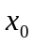,  and 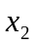. Write down the Lagrange interpolation polynomial for this case.
- Consider following polynomial: 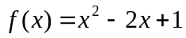.
i) Why the bisection algorithm can not be used to find the roots of f(x) ?
ii) Write down explicitly the Newton algorithm for this polynomial.
iii) Will the Newton algorithm be working properly?
- Suppose we want to compute 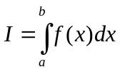with an integration formula of order 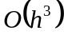 in the multiple application form. Suppose that for n=10 segments we get a truncation error of 0.01. How many subdivisions n would be needed to reach a truncation error smaller than 0.00001 ?
- Explain the idea of the Gauss integration formula.
- Show on a figure the local and global truncation error for the first two iterations of a ODE solver.
- Solve graphically the ODE 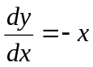.
- Explain how numerical adaptive ODE solvers works.
- When is a numerical method for solving differential equations considered to be unstable ? Which parameter(s) is (are) influencing this stability (or instability) ?
- In general the total error done by any numerical algorithm has two main contributions. Give these two contributions and explain where they come from. What can you do to minimize each of these contributions?

